ASSIGNMENT – 2
- Open Wireshark, capture network traffic while you refresh the Flipkart homepage, and identify one packet each belonging to the Application, Transport, Internet, and Network Access layers by examining their headers.

Theory
Wireshark is a network protocol analyzer used to capture and inspect network packets. When we open a website such as Flipkart, data travels through different layers of the TCP/IP model. Each layer performs a specific function during communication.

Steps / Procedure
- Open Wireshark on your laptop.
- Select your active network interface, such as Wi-Fi or Ethernet.
- Click Start Capturing Packets.
- Open a web browser and visit https://www.flipkart.com/.
- Refresh the homepage and wait for 10–15 seconds.
- Return to Wireshark and click the Stop button.
- Examine the captured packets in the packet list.
- Select packets and expand their protocol headers in the packet details pane.
- Identify one packet or protocol for each of the four TCP/IP layers.

Observation Table
No. | TCP/IP Layer | Protocol | Information Observed
1 | Application | DNS / TLS | DNS query for a domain name or TLS communication details
2 | Transport | TCP / UDP | Source port, destination port, and transport information
3 | Internet | IPv4 / IPv6 | Source IP address and destination IP address
4 | Network Access | Ethernet II | Source MAC address and destination MAC address

- Create a table comparing the OSI and TCP/IP models, listing all layers side-by-side, and for each layer, give a real-world example from any app you use (e.g., WhatsApp message, Zomato order).

OSI Layer (7 Layers) | TCP/IP Layer (4 Layers) | Function | Real-World Example
7. Application | Application | Provides network services to applications. | Sending a message on WhatsApp or placing an order on Zomato.
6. Presentation | Application | Handles data formatting, encryption, and compression. | Encrypting a WhatsApp message or viewing an Instagram image.
5. Session | Application | Establishes and manages communication sessions. | Maintaining a Google Meet video-call session.
4. Transport | Transport | Delivers data between applications using TCP or UDP. | Transporting data during a YouTube video stream.
3. Network | Internet | Handles IP addressing and routing between networks. | Routing a Zomato order request to its server using IP addresses.
2. Data Link | Network Access | Transfers frames across a local network using MAC addresses. | Sending data from a phone to a Wi-Fi router.
1. Physical | Network Access | Transmits raw bits through physical or wireless signals. | Sending data through Wi-Fi radio signals or network cables.

- Given a screenshot of a TCP segment header (provided by your trainer), label the fields that belong to the Transport layer and explain what each field does in 1-2 lines.<br><br><em><strong>Hint:</strong> Look for fields like Source Port, Destination Port, Sequence Number, etc.</em>

TCP Header Fields and Their Functions
No. | TCP Header Field | Function
1 | Source Port | Identifies the port number of the sending application.
2 | Destination Port | Identifies the port number of the receiving application.
3 | Sequence Number | Indicates the sequence position of data bytes, helping arrange data in the correct order.
4 | Acknowledgment Number | Indicates the next byte expected from the other device when acknowledgment is used.
5 | Header Length (Data Offset) | Specifies the size of the TCP header.
6 | Flags (Control Bits) | Control the connection and data transfer. Examples include SYN, ACK, FIN, and RST.
7 | Window Size | Indicates how much data the receiver is currently willing to accept.
8 | Checksum | Detects errors in the TCP header and data.
9 | Urgent Pointer | Indicates the end of urgent data when the URG flag is set.
10 | Options | Carries optional information, such as the Maximum Segment Size (MSS).
11 | Padding | Adds extra bits so the TCP header ends on a 32-bit boundary.

- Draw a diagram showing how a message sent from your device to Instagram's server passes through each TCP/IP layer, and annotate what happens at each step using simple app-related terms (e.g., 'message split into packets', 'IP address added', etc.).

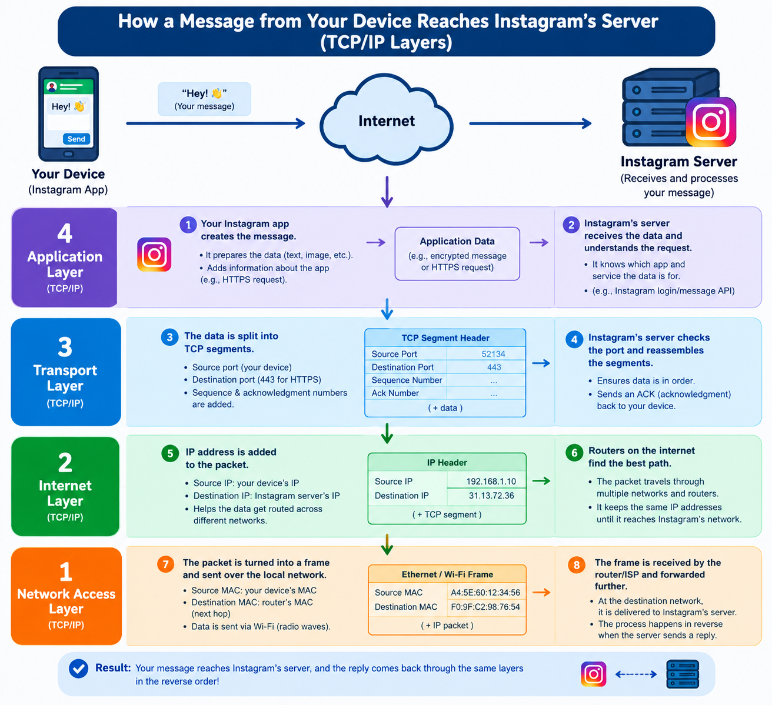

- Pick any one packet you captured in Wireshark and write which TCP/IP layer it belongs to, how you identified it, and what real-world action in an app (like sending a WhatsApp message or booking a ticket on BookMyShow) it represents.

Wireshark Packet Analysis
1. Packet Selected: TCP Packet
2. TCP/IP Layer: Transport Layer
3. How I Identified It:
I identified the packet by checking the Protocol column in Wireshark, which showed TCP. In the packet details, I examined the TCP header, including the source port, destination port, and sequence number.
4. Real-World Action:
This packet represents data transmission when I send a message on WhatsApp or book a movie ticket on BookMyShow. TCP helps deliver data reliably and keeps it in the correct order when required.

